Lab: Data Types and Variables
Submit your solutions in the SoftUni judge system at: https://alpha.judge.softuni.org/contests/data-types-and-variables-lab/1242
- Echo Type
Write a JS function that takes one parameter and prints on two lines the type of the parameter and then one of the following:
- If the parameter type is either string or number, print its value
- Otherwise, print the text 'Parameter is not suitable for printing'

Examples
Input | Output
'Hello, JavaScript!' | string  Hello, JavaScript!
18 | number  18
null | object  Parameter is not suitable for printing

Hints
- Write a function that receives a single parameter.
- Use the console.log function to print text on the console. Each call prints a new line automatically.
- The typeof operator is used to determine the data type of a given value.
- Concatenate Names
Write a function, which receives two names as string parameters and a delimiter. Print the names joined by the delimiter.

Examples
Input | Output
'John',  'Smith',  '->' | John->Smith
'Jan',  'White',  '<->' | Jan<->White
'Linda',  'Terry',  '=>' | Linda=>Terry

Hints
Use string interpolation.
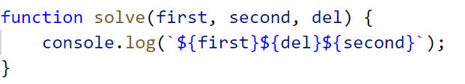

Right Place
You will receive 3 parameters (string, char, string).
The first string will be a word with a missing char replaced with an underscore '_'.
You have to replace the missing character (underscore) of the first string with the character passed as the second parameter and compare the result with the second string.
If they are equals, you should print "Matched", otherwise print "Not Matched".

Examples
Input | Output
'Str_ng', 'I', 'Strong' | Not Matched
'Str_ng', 'i', 'String' | Matched

Hints
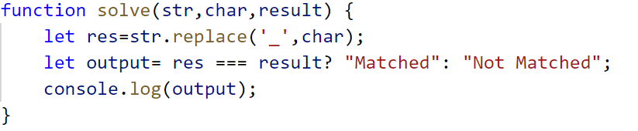

Integer and Float
You will receive 3 numbers. Your task is to find their sum and print result to the console in the following format:
`{sum} - {type of the number (Integer or Float)}`

Examples
Input | Output
9, 100, 1.1 | 110.1 - Float
100, 200, 303 | 603 - Integer

Hints
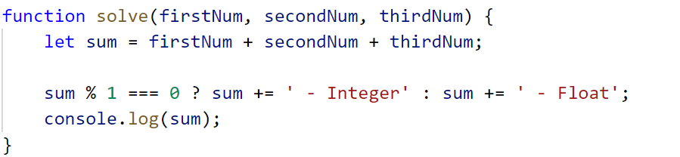

Amazing Numbers
Write a function, which as input will receive a number.
Check and print if it is amazing or not into the following format:
"{number} Amazing? {True or False}"
An amazing number includes the digit 9 the sum of its digits.
Examples for amazing numbers are 1233 (1 + 2 + 3 + 3 = 9), 583472 (5 + 8 + 3 + 4 + 7 + 2 = 29)

Examples
Input | Output
1233 | 1233 Amazing? True
999 | 999 Amazing? False

Hints
Use includes()
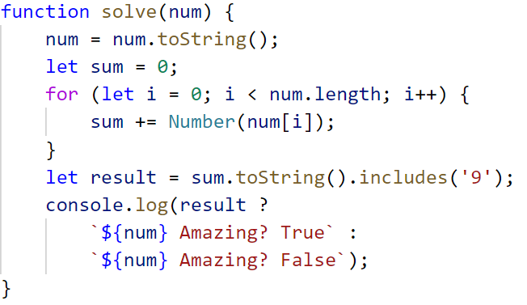

Gramophone
Write a function, which as input will receive 3 parameters (strings)
- The first string is the name of the band
- The second string is the name of the album
- The third is holding a song name from the album
You have to find out how many times the plate will rotate the given song from the album.
The plate makes a full rotation every 2.5 seconds.
The song duration in seconds is calculate by the given formula:
(albumName.length * bandName.length) * song-name.length / 2
As output, you should print the following message:
`The plate was rotated {rotations} times.`
Rotations should be rounded up.

Examples
Input | Output
'Black Sabbath', 'Paranoid', 'War Pigs' | The plate was rotated 167 times.
'Rammstein', 'Sehnsucht', 'Engel' | The plate was rotated 81 times.

Hints
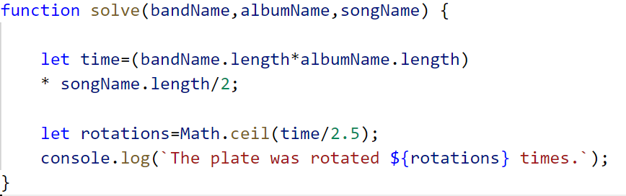

Required reading
Write a function to help Ivan calculate how many hours a day he has to spend reading the necessary literature from the list given for the summer vacation.
As input, you will receive 3 parameters:
- Number of pages of the current book - integer [1… 1000]
- Pages read in 1 hour - integer [1… 1000]
- The number of days for which you must read the book - integer [1… 1000]
As output print on the console the number of hours, that Ivan has to read each day.

Examples
Input | Output | Explanations
212,  20 ,  2 | 5.3 | Total time to read the book: 212 pages / 20 pages per hour = 10.6 hours  Required hours per day: 10.6 hours / 2 days = 5.3 hours per day
432,  15 ,  4 | 7.2 | Total reading time of the book: 432 pages / 15 pages per hour = 28.8 hours  Required hours per day: 28.8 hours / 4 days = 7.2 hours per day

Centuries to Minutes
Write a program that receives a number of centuries and converts it to years, days, hours, and minutes.

Examples
Input | Output
1 | 1 centuries = 100 years = 36524 days = 876576 hours = 52594560 minutes
5 | 5 centuries = 500 years = 182621 days = 4382904 hours = 262974240 minutes

Hint
- Assume that a year has 365.2422 days on average (the Tropical year).

Solution
You might help yourself with the code below:
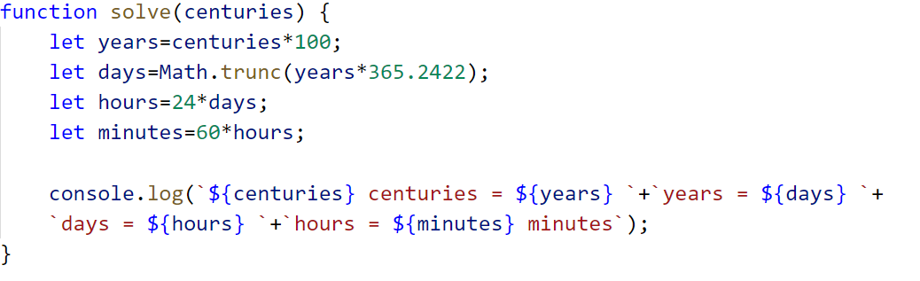
- Special Numbers
Write a program that receives a number n. For all numbers in the range [1…n] print the number and if it is special or not (True / False).
- A number is special when its sum of digits is 5, 7 or 11.

Examples
Input | Output
15 | 1 -> False  2 -> False  3 -> False  4 -> False  5 -> True  6 -> False  7 -> True  8 -> False  9 -> False  10 -> False  11 -> False  12 -> False  13 -> False  14 -> True  15 -> False
20 | 1 -> False  2 -> False  3 -> False  4 -> False  5 -> True  6 -> False  7 -> True  8 -> False  9 -> False  10 -> False  11 -> False  12 -> False  13 -> False  14 -> True  15 -> False  16 -> True  17 -> False  18 -> False  19 -> False  20 -> False

Hints
To calculate the sum of digits of given number num, you might repeat the following: sum the last digit (num % 10) and remove it (sum = sum / 10) until num reaches 0. Use parseInt() while dividing to get only integer numbers.
- Triples of Latin Letters
Write a program that receives a string of number n and print all triples of the first n small Latin letters, ordered alphabetically:

Examples
Input | Output
'3' | aaa  aab  aac  aba  abb  abc  aca  acb  acc  baa  bab  bac  bba  bbb  bbc  bca  bcb  bcc  caa  cab  cac  cba  cbb  cbc  cca  ccb  ccc
2 | aaa  aab  aba  abb  baa  bab  bba  bbb

Hints
Perform 3 nested loops from 0 to n. For each number num print its corresponding Latin letter as follows:
The function String.fromCharCode() gets the value in decimal and transforms it to a character from the ASCII table.

